PROJECT DOCUMENTATION

**IOT-BASED GAS LEAKAGE MONITORING AND ALERTING SYSTEM**

TEAM ID: PNT2022TMID11701

TEAM MEMBERS:

SARULATHA D

SWATHI R

SUJITHA S

PRIYANKA M

# ABSTRACT

IoT is an expanding network of physical devices that are linked with different types of sensors and with the help of connectivity to the internet, they can exchange data. Through IoT, the internet has now extended its roots to almost every possible thing present around us and is no more limited to our personal computers and mobile phones. Safety, the elementary concern of any project, has not been left untouched by IoT. Gas Leakages in open or closed areas can prove to be dangerous and lethal. The traditional Gas Leakage Detector Systems though have great precision, fail to acknowledge a few factors in the field of alerting people about the leakage. Therefore, we have used IoT technology to make Gas Leakage monitoring and altering involving calling, sending a text message and an e-mail to the concerned authority, and an ability to predict hazardous situations so that people could be made aware in advance by performing data analytics on sensor readings. Leakage of any kind of gas has been a concern in recent years, whether it is in a residential setting, a business, a cafe, or a canteen. In this paper development of an IoT-based gas wastage monitoring, leakage detecting, and alerting system is proposed. This paper elaborates design of such an intelligent system that will help save gas and smartly prevent accidents.

# CONTENTS

1. INTRODUCTION
   1. Project Overview
   2. Purpose
2. LITERATURE SURVEY
   1. Existing problem
   2. References
   3. Problem Statement Definition
3. IDEATION & PROPOSED SOLUTION
   1. Empathy Map Canvas
   2. Ideation & Brainstorming
   3. Proposed Solution
   4. Problem Solution fit
4. REQUIREMENT ANALYSIS
   1. Functional requirement
   2. Non-Functional requirements
5. PROJECT DESIGN
   1. Data Flow Diagrams
   2. Solution & Technical Architecture
   3. User Stories
6. PROJECT PLANNING & SCHEDULING
   1. Sprint Planning & Estimation
   2. Sprint Delivery Schedule
7. CODING & SOLUTION
   1. Feature 1
   2. Feature 2
8. TESTING
   1. Defect Analysis
   2. Test Case Analysis
9. RESULTS
   1. Performance Metrics
10. ADVANTAGES & DISADVANTAGES
11. CONCLUSION
12. FUTURE SCOPE
13. APPENDIX
    1. GitHub And Project Demo Link

# 1. INTRODUCTION

## 1.1 PROJECT OVERVIEW

We design and develop a proposed system that includes some safety factors. Safety has been a major issue in today’s day-to-day life. LPG is a petroleum gas that is most commonly used in residential and commercial places. For industrial plants, it has been used fuels like petrol and diesel. These gases are filled in cylinders which are easily un damageable. But leakage can take place through pipes or regulators or knobs which may cause accidents like suffocation, uneasiness, or sometimes may catch fire and short circuit as well. The main aim of this project is to develop a system that can detect gas leakage. On detection, it will send an alert SMS and the gas supply knob of the cylinder will be switched off automatically. The system can be taken as a small attempt in connecting the existing primary gas detection methods to a mobile platform integrated with IoT platforms. The gases are sensed in an area of a 1m radius of the rover and the sensor output data are continuously transferred to the local server. The accuracy of sensors is not up to the mark thus stray gases are also detected which creates an amount of error in the outputs of the sensors, especially in the case of methane. Further, the availability and storage of toxic gases like hydrogen sulfide also create problems for testing the assembled hardware. As the system operates outside the pipeline, the complication of system maintenance and material selection of the system in case of corrosive gases is reduced. Thus, the system at this stage can only be used as a primary indicator of leakage inside a plant.

## 1.2 PURPOSE

The design of a sensor-based automatic gas leakage detector with an alert and control system has been proposed. This is an affordable, less power use, lightweight, portable, safe, user-friendly, efficient, multi-featured, and simple system device for detecting gas. Gas leakage detection will not only provide us with significance in the health department but will also lead to a raise in our economy because when gas leaks it not only contaminates the atmosphere but also wastes gases that will hurt our economy. The need for ensuring safety in workplaces is expected to be the key driving force for the market over the coming years

**2. LITERATURE SURVEY**

|  |  |  |  |
| --- | --- | --- | --- |
| **S.NO** | **PAPER NAME** | **AUTHOR’S NAME** | **DESCRIPTION** |
| 1 | Internet of Things (IOT)  Based Gas Leakage  Monitoring and Alerting  System with MQ-2 Sensor | Rohan Chandra Pandey, Manish Verma, Lumesh  Kumar Sah | This paper proposes a methodology of using a real time gas leakage monitoring and sensing the output levels of gas has been clearly observed by the help of this system. |
| 2 | IOT based Gas Leakage  Detection system with  Database Logging, Prediction and Smart Alerting. | Chautali Bagwe, vidya Ghadi, Vinayshri Naik, Neha Kunte. | The system provides constant monitoring and detection of gas leakage along with storage of data in database for predictions and analysis. The IOT components used helps in making the system much more cost effective in comparison with traditional Gas detector systems |
| 3 | A Gas leakage detector using IOT | Ch. Manohar Raju and N. Sushma Rani | This paper proposes a prototype depicting a mini mobile robot which is capable to detect gas leakage in hazardous places. Whenever there is an occurrence of gas leakage in a particular place the robot immediately read and sends the data to android mobile through wireless communication like Bluetooth. |

# 

## 2.1 EXISTING PROBLEM

Materials tend to lose their properties with the environmental effects and aging, thereby causing degradation in the sensor response, which is known as the drift error. Most of the studies did not consider the aging effect (long-term stability) which is essential for sensor implementation in a real-world application.

## 2.2 REFERENCES

1. Mahalingam, A., R. T. Naayagi, and N. E. Mastorakis. "Design and implementation of an economic gas leakage detector." Recent Researches in Applications of Electrical and Computer Engineering, pp. 20-24, 2012.

1. Attia, Hussain A., and Halah Y. Ali. "Electronic Design of Liquefied Petroleum

Gas Leakage Monitoring, Alarm, and Protection System Based on Discrete Components." International Journal of Applied Engineering Research, vol. 11, no. 19, pp. 9721-9726, 2016.

1. Apeh, S. T., K. B. Erameh, and U. Iruansi. "Design and Development of Kitchen Gas Leakage Detection and Automatic Gas Shut off System." Journal of Emerging Trends in Engineering and Applied Sciences, vol. 5, no. 3, pp. 222228, 2014.

1. T.Soundarya, J.V. Anchitaalagammai, G. Deepa Priya, S.S. Karthick Kumar, “C-

Leakage: Cylinder LPG Gas Leakage Detection for Home Safety,” IOSR Journal of Electronics and Communication Engineering, vol. 9, no. 1, Ver. VI, pp. 53-58, Feb. 2014.

1. Ashish Shrivastava, RatneshPrabhaker, Rajeev Kumar, Rahul Verma, "GSM based gas leakage detection system." International Journal of Emerging Trends in Electrical and Electronics, vol. 3, no. 2, pp. 42-45, 2013.

## 2.3 PROBLEM STATEMENT DEFINITION

Workers who are engaged in a busy industry packed with gas either harmful or harmless needs a way to monitor their gas pipelines continuously and detect early if there is any leakage of gas in their surroundings so that they can work efficiently on major crises rather than worrying about monitoring or leakage of gas, this will indeed reduce the manpower of that industry and create a peaceful environment.

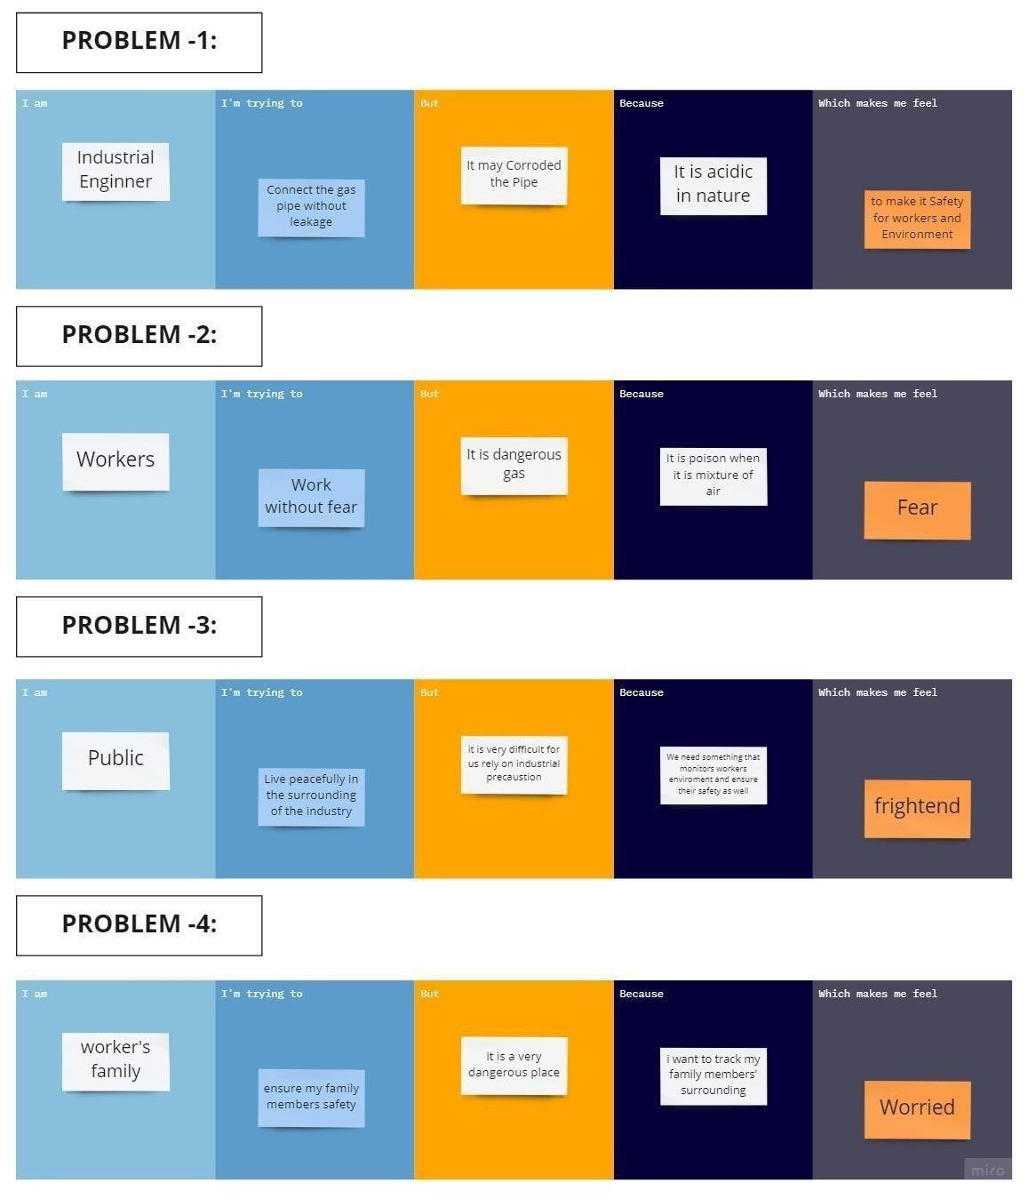

# 3. IDEATION PHASE

**3.1** [**EMPATHY MAP CANVAS**](https://github.com/IBM-EPBL/IBM-Project-30560-1660148882/tree/main/Ideation%20Phase/Empathy%20Map%20Canvas)

Empathy Map Canvas: An empathy map is a simple, easy-to-digest visual that captures knowledge about a user’s behaviours and attitudes. It is a useful tool to help teams better understand their users. Creating an effective solution requires understanding the true problem and the person who is experiencing it. The exercise of creating the map helps participants consider things from the user’s perspective along with his or her goals and challenges.

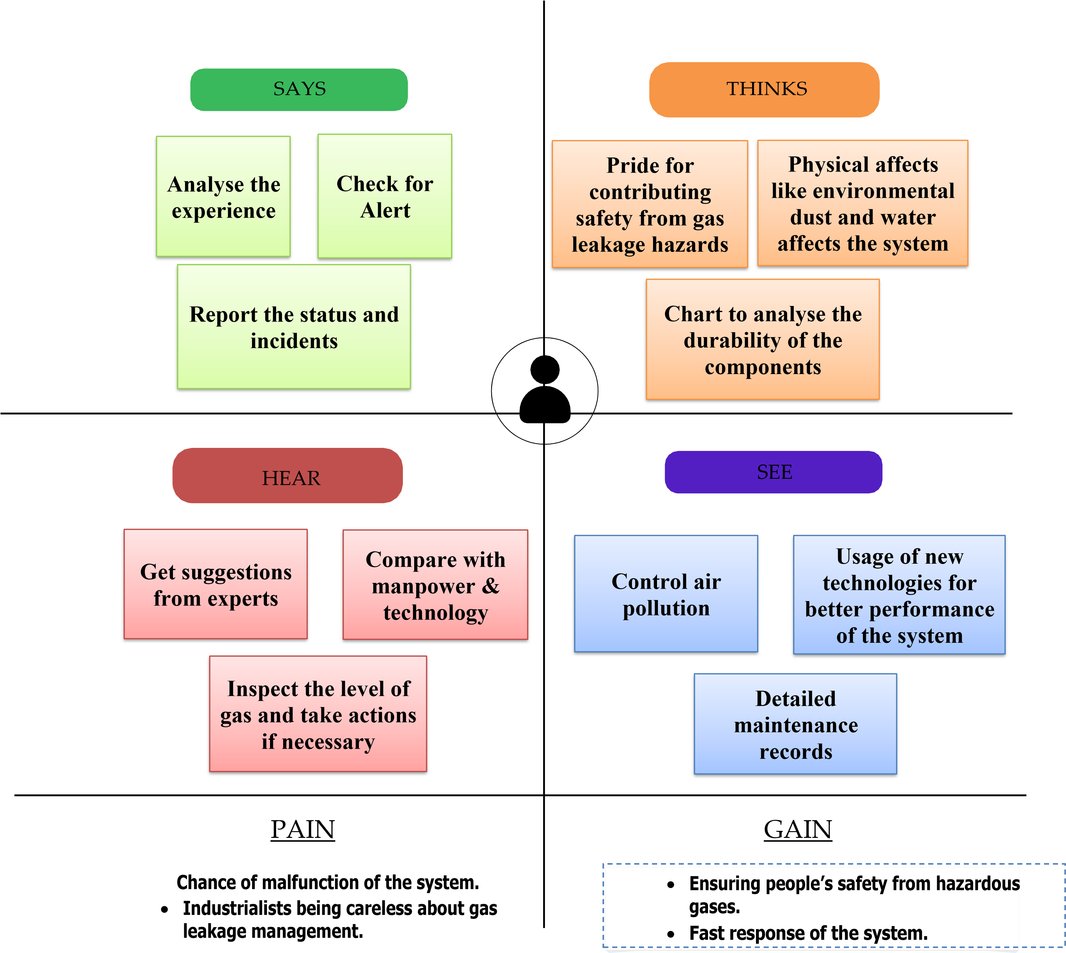

**3.2 BRAINSTORM & IDEA PRIORITIZATION TEMPLATE:**

Brainstorming provides a free and open environment that encourages everyone within a team to participate in the creative thinking process that leads to problem-solving. Prioritizing volume over value, out-of-the-box ideas are welcome and built upon, and all participants are encouraged to collaborate, helping each other develop a rich amount of creative solutions.

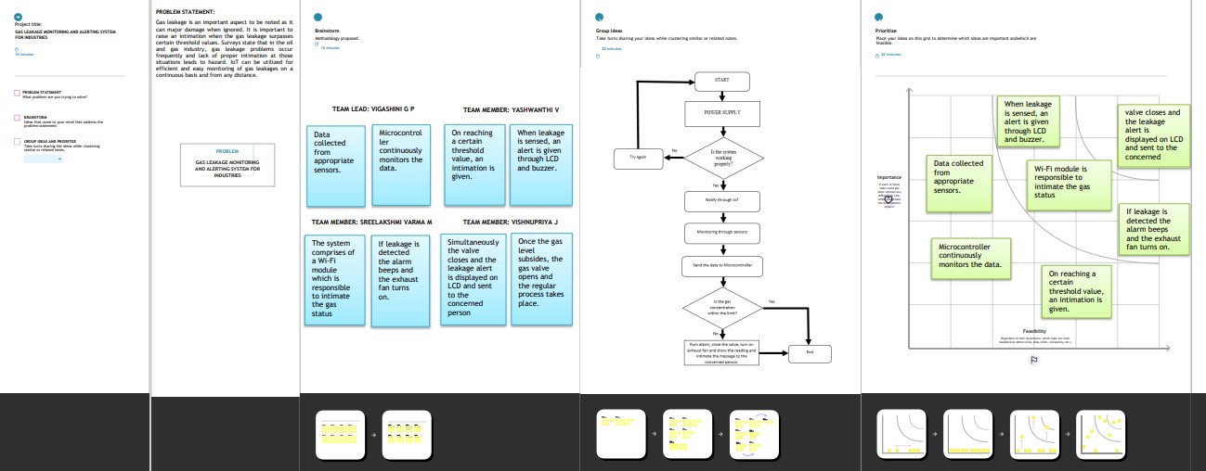

## 3.3 PROPOSED SOLUTION

The system can be taken as a small attempt in connecting the existing primary gas detection methods to a mobile platform integrated with IoT platforms. The gases are sensed in an area of a 1m radius of the rover and the sensor output data are continuously transferred to the local server. The accuracy of sensors is not up to the mark thus stray gases are also detected which creates an amount of error in the outputs of the sensors, especially in the case of methane. Further, the availability and storage of toxic gases like hydrogen sulphide also create problems for testing the assembled hardware. As the system operates outside the pipeline, the complication of system maintenance and material selection of the system in case of corrosive gases is reduced. Thus the system at this stage can only be used as a primary indicator of leakage inside a plant.

## 3.4 PROBLEM-SOLUTION FIT

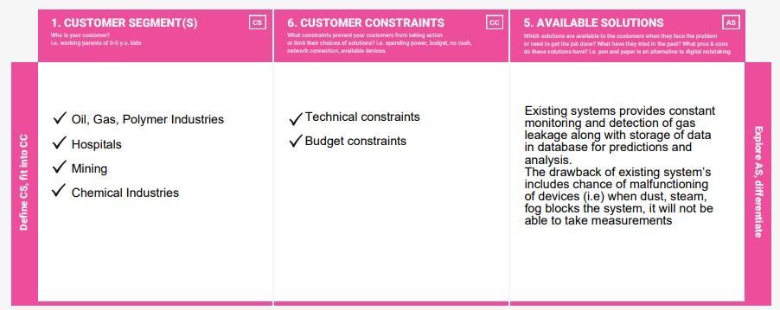

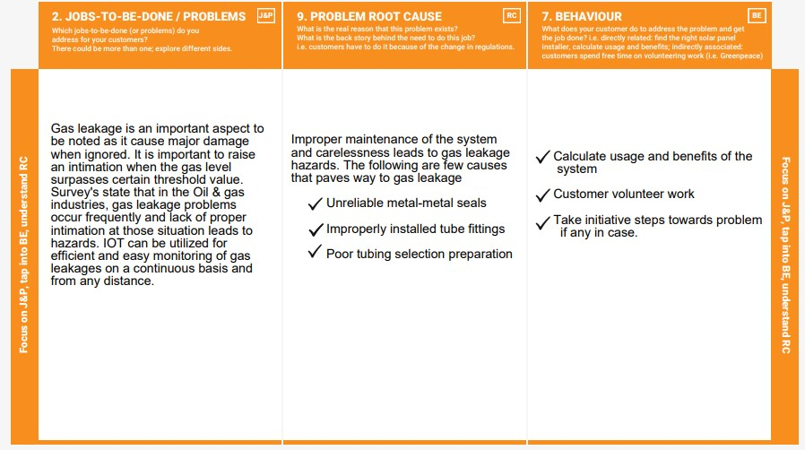

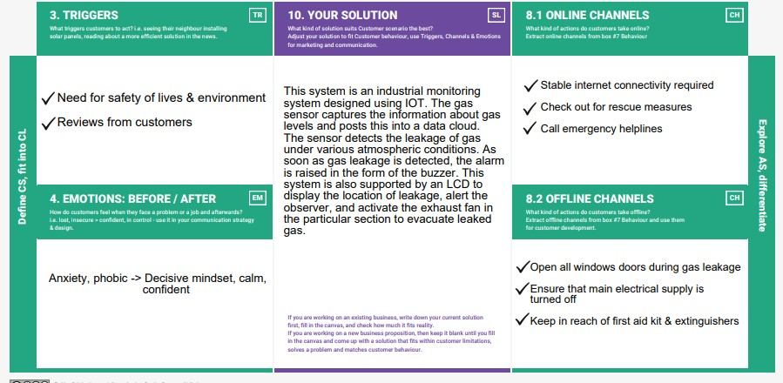

# 4. REQUIREMENT ANALYSIS

## 4.1 FUNCTIONAL REQUIREMENT

Following are the functional requirements of the proposed solution.

|  |  |  |
| --- | --- | --- |
| **FR No.** | **Functional Requirement (Epic)** | **Sub Requirement (Story / Subtask)** |
| FR-1 | Data fetch | The details of the gas leaked will be transferred to IOT system. |
| FR-2 | Transferring to user | IOT, WIFI module |
| FR-3 | Receiving in the user end | Gas level details will be displayed through LCD, an alarm will be beeps and the same data will be sent to the user mobile or pc. |

## 4.2 NON-FUNCTIONAL REQUIREMENT

Following are the non-functional requirements of the proposed solution.

|  |  |  |
| --- | --- | --- |
| **FR No.** | **Non-Functional Requirement** | **Description** |
| NFR-1 | Usability | Set of techniques for design and development are implemented. |
| NFR-2 | Security | Strategical improvement of the process ensures less risk. |
| NFR-3 | Reliability | Accuracy and consistency check is properly maintained. |
| NFR-4 | Performance | Achieves the goal and contributes to the existing problem in the industry. |
| NFR-5 | Availability | Information about the availability of resources are identified. |
| NFR-6 | Scalability | Probability of performance is high. |

# 5. PROJECT DESIGN

## 5.1 DATA FLOW DIAGRAM

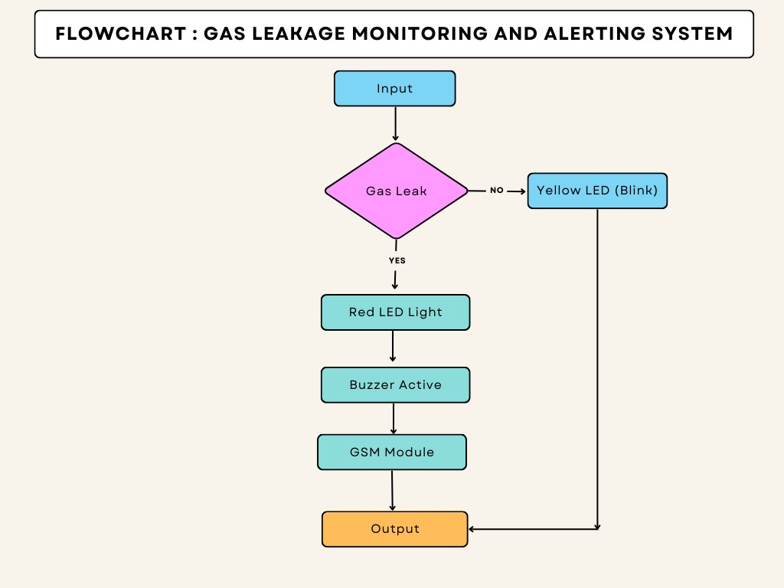

## 5.2 SOLUTION AND ARCHITECTURE

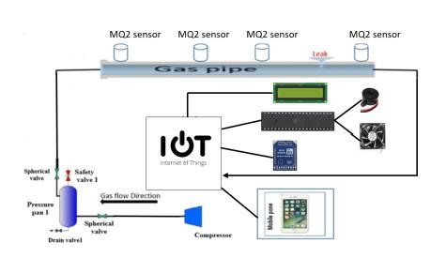

## 5.3 USER STORIES

|  |  |  |  |  |  |  |
| --- | --- | --- | --- | --- | --- | --- |
| **User Type** | **Functional**  **Requirement**  **(Epic)** | **User**  **Story**  **Number** | **User Story**  **/Task** | **Acceptance criteria** | **Priority** | **Release** |
| **Customer**  **(Mobile user)** | Registration | USN-1 | As a user, I can create an account in the application provided. | I can access my account/ dashboard | High | Sprint- 1 |
|  |  | USN-2 | As a user, I registered using my  Gmail | I can receive a confirmation email | High | Sprint- 1 |

|  |  |  |  |  |  |  |
| --- | --- | --- | --- | --- | --- | --- |
|  |  | USN-3 | As a user, I can successfully install the app. | I can register & access the dashboard. | Low | Sprint- 2 |
|  | Login | USN-4 | As a user, I can log in using my  Gmail and password easily. | The login process was easy and simple to access dashboard  . | High | Sprint- 1 |
| **Customer**  **(Web user)** | Registration | WUSN-  1 | As a web user, I can log in to the web dashboard just like a website. | I can register & access the dashboard. | High | Sprint- 2 |
|  | Dashboard | WUSN-  2 | As a user, I can view the alert/warning SMS in the web application. | I can log in to the website using my login credentials | High | Sprint- 2 |
| **Customer**  **Care**  **Executive** |  | CCE-1 | A customer care executive will always be available in the interaction with the customer to clarify the queries. | An executive will clarify the doubts and note down the complaints of the application if any. | High | Sprint- 2 |
| **Administrator** |  | ADMIN  -1 | I as an Admin can access and view the data or information provided by the application &can also check, and analyze the threshold value of the gas. | The details of the gas leakage level of the gas are provided to the users through SMS when an alerting sound is received. | High | Sprint- 1 |

# 6. PROJECT PLANNING AND SCHEDULING

Fundamentally, ‘Project planning’ is all about choosing and designing effective policies and methodologies to attain project objectives. While ‘Project scheduling’ is a procedure of assigning tasks to get them completed by allocating appropriate resources within an estimated budget and time frame.

## 6.1 SPRINT PLANNING AND ESTIMATION

|  |  |  |  |  |  |
| --- | --- | --- | --- | --- | --- |
| **Sprint** | **Functional**  **Requirement**  **(Epic)** | **User Story / Task** | **Story Points** | **Priority** | **Team**  **Members** |
| Sprint-1 | Resources  Initialization | Create and initialize accounts in IBM cloud and  NODE-RED  Services. | 1 | LOW | Sarulatha D  Swathi R  Sujitha S  Priyanka M |
| Sprint-1 | Local  Server/Software  Run | Create a Required device in the IBM cloud and the python code | 1 | MEDIUM | Sarulatha D  Swathi R  Sujitha S  Priyanka M |
| Sprint-2 | Push the server/software to cloud | Push the code from  Sprint 1 to the cloud so it can be accessed from anywhere | 2 | MEDIUM | Sarulatha D  Swathi R  Sujitha S  Priyanka M |
| Sprint-3 | Hardware  initialization | Integrate the hardware to be able to access the cloud functions and provide inputs to the same using Node-RED | 2 | HIGH | Sarulatha D  Swathi R  Sujitha S  Priyanka M |
| Sprint -4 | UI/UX  Optimization  &  Debugging | Optimize all the shortcomings and provide a better user experience. | 2 | LOW | Sarulatha D  Swathi R  Sujitha S  Priyanka M |

## 6.2 SPRINT DELIVERY SCHEDULE

|  |  |  |  |  |  |  |
| --- | --- | --- | --- | --- | --- | --- |
| **Sprint** | **Total**  **Story**  **Points** | **Duration** | **Sprint**  **Start**  **Date** | **Sprint End**  **Date**  **(Planned)** | **Story**  **Points**  **Completed**  **(as on**  **Planned**  **End Date)** | **Sprint**  **Release Date(A**  **actual)** |
| Sprint-1 | 20 | 6 Days | 24 Oct 2022 | 29 Oct 2022 | 20 | 29 Oct 2022 |
| Sprint-2 | 20 | 6 Days | 31 Oct 2022 | 05 Nov 2022 | 20 | 31 Oct 2022 |
| Sprint-3 | 20 | 6 Days | 07 Nov  2022 | 12 Nov 2022 | 20 | 07 Nov 2022 |
| Sprint-4 | 20 | 6 Days | 14 Nov  2022 | 19 Nov 2022 | 20 | 14 Nov 2022 |

# 7. CODING AND SOLUTION

#include LiquidCrystal lcd(5,6,8,9,10,11); int redled = 2; int greenled = 3; int buzzer = 4; int sensor = A0; int sensorThresh = 400; void setup() { pinMode(redled, OUTPUT); pinMode(greenled,OUTPUT); pinMode(buzzer,OUTPUT); pinMode(sensor,INPUT); Serial.begin(9600); lcd.begin(16,2);

} void loop() { int analogValue = analogRead(sensor); Serial.print(analogValue); if(analogValue>sensorThresh) { digitalWrite(redled,HIGH); digitalWrite(greenled,LOW); tone(buzzer,1000,10000); lcd.clear(); lcd.setCursor(0,1); lcd.print("ALERT"); delay(1000); lcd.clear(); lcd.setCursor(0,1); lcd.print("EVACUATE"); delay(1000);

} else { digitalWrite(greenled,HIGH); digitalWrite(redled,LOW); noTone(buzzer);

lcd.clear(); lcd.setCursor(0,0); lcd.print("SAFE"); delay(1000); lcd.clear(); lcd.setCursor(0,1); lcd.print("ALL CLEAR"); delay(1000);

}

}

## 7.1 FEATURE 1

As stated earlier the sensing elements or the sensors are the most essential part of the whole system. Without the proper functioning of these sensing elements, the system as a whole has nothing to do with the environment. The proposed system uses a temperature sensor, humidity sensor, and gas sensor.

The temperature sensor senses the temperature level of the environment in which the system is set. This has some pre-set threshold values, above or below which it reports negative.

The humidity sensor is responsible for monitoring the humidity level of the surrounding. Again this works on the principle of threshold value maintenance.

The gas sensor, being the heart of the system, senses the presence of gas in the air around it. And if it senses the presence of any gas, it reports negative. And the system will take over further.

## 7.2 FEATURE 2

Another solid part of the prototype is its alerting system. While the sensing elements are responsible for sensing the hazardous situation, the alerting system is responsible for alerting the user with the light and buzzer. Also, the system notifies the user with a message if he/she is away.

# 8. TESTING

## USER ACCEPTANCE TESTING

**User Acceptance Testing (UAT)** is a type of testing performed by the end-user or the client to verify/accept the software system before moving the software application to the production environment. UAT is done in the final phase of testing after functional, integration, and system testing is done

## 8.1 DEFECT ANALYSIS

This report shows the number of resolved or closed bugs at each severity level, and how they were resolved

|  |  |  |  |  |  |
| --- | --- | --- | --- | --- | --- |
| **Resolution** | **Severity 1** | **Severity 2** | **Severity 3** | **Severity 4** | **Subtotal** |
| By Design | 10 | 4 | 2 | 3 | 20 |
| Duplicate | 1 | 0 | 3 | 0 | 4 |
| External | 2 | 3 | 0 | 1 | 6 |
| Fixed | 11 | 2 | 4 | 20 | 37 |
| Not Reproduced | 0 | 0 | 1 | 0 | 1 |
| Skipped | 0 | 0 | 1 | 1 | 2 |
| Won't Fix | 0 | 5 | 2 | 1 | 8 |
| Totals | 24 | 14 | 13 | 26 | 77 |

## 8.2 TEST CASE ANALYSIS

This report shows the number of test cases that have passed, failed, and untested

|  |  |  |  |  |
| --- | --- | --- | --- | --- |
| **Section** | **Total Cases** | **Not Tested** | **Fail** | **Pass** |
| Print Engine | 7 | 0 | 0 | 7 |
| Client Application | 51 | 0 | 0 | 51 |
| Security | 2 | 0 | 0 | 2 |
| Outsource Shipping | 3 | 0 | 0 | 3 |

|  |  |  |  |  |
| --- | --- | --- | --- | --- |
| Exception Reporting | 9 | 0 | 0 | 9 |
| Final Report Output | 4 | 0 | 0 | 4 |
| Version Control | 2 | 0 | 0 | 2 |

# 9. RESULTS

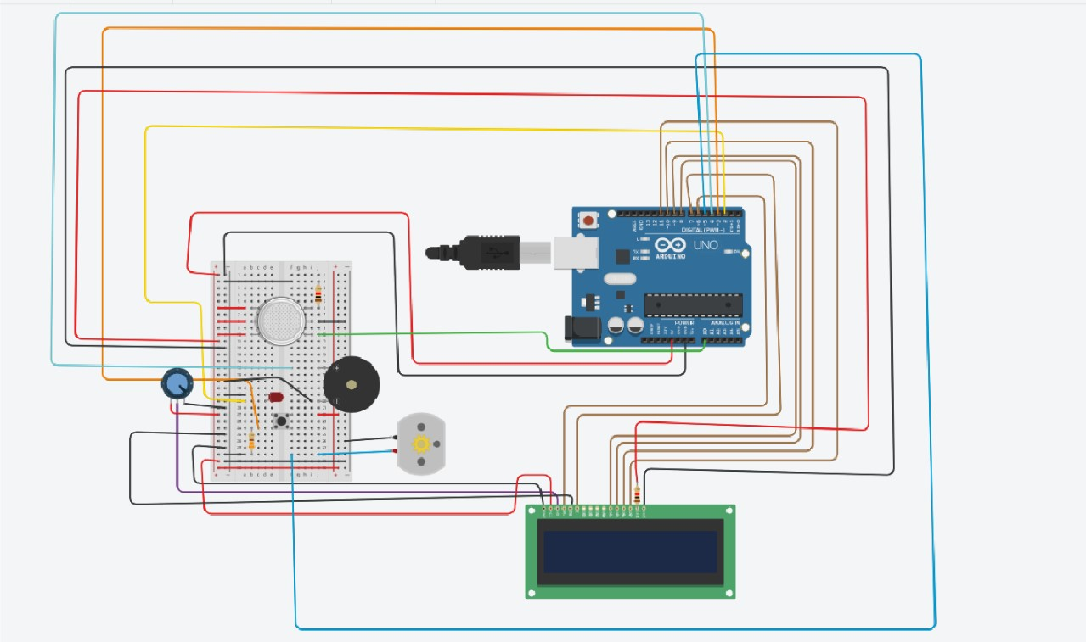

This technique has been tested by leaks of gas in almost about sensors, MQ2 gas sensor sends the signal to the Arduino UNO after detecting the gas leakage. Arduino to another externally connected device such as LCDs, and buzzers. In practice, results being noticed by the people surrounding the area are displayed on the LCD and the buzzer sound indicates the danger to the people by making a beep sound.

# PERFORMANCE METRICS

Performance metrics are defined as figures and data representative of an organization’s actions, abilities, and overall quality. There are many different forms of performance metrics, including sales, profit, return on investment, customer happiness, customer reviews, personal reviews, overall quality, and reputation in a marketplace. Performance metrics can vary considerably when viewed through different industries.

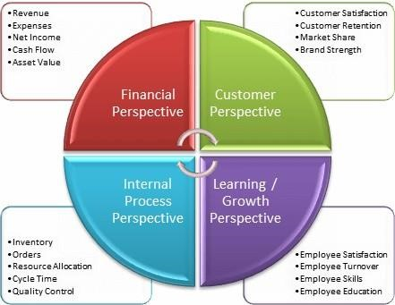

## 10. ADVANTAGES AND DISADVANTAGES

The advantages of the system are pretty much straightforward. The world now has a mechanism to detect gas leaks with great ease of accuracy. And in addition, the system manages to send messages to the users which makes the system more mobile.

The major drawback of the system is that it highly relies on sensors and other electronic elements which are always prone to damage. So this in turn increases the sensitivity of the system as a whole. Secondly, the range of the sensor used plays a vital role in the efficiency and accuracy of the results. So that must be taken care of.

## 11. CONCLUSION

An advantage of this simple gas leak detector is its simplicity and its ability to warn about the leakage of LPG gas. This system uses the GSM technique to send an alert message to a respective person if no one is there in the house and then gas leaks occur, the GSM module is there to send immediate messages to the respective person regarding the gas leak. The main advantage of this system is that it off the regulator knob of the cylinder automatically when gas leakage is detected. It can conclude that detection of the LPG gas leakage is incredible in the project system.

Applicable usefully for industrial and domestic purposes.

## 12. FUTURE SCOPE

Leakage of any kind of gas has been a concern in recent years, whether it is in a residential setting, a business, a cafe, or a canteen. In this paper development of an

IoT-based gas wastage monitoring, leakage detecting, and alerting system is proposed. This paper elaborates design of such an intelligent system that will help save gas and smartly prevent accidents.

## 13. APPENDIX

### 13.1 GITHUB AND PROJECT DEMO LINK

**GITHUB LINK:**

#### [IBM-EPBL/IBM-Project-26676-1660033145: Gas Leakage monitoring & Alerting system for Industries (github.com)](https://github.com/IBM-EPBL/IBM-Project-26676-1660033145)